DEMO Walkthrough

Slide 13 done
Run this command
& "c:\Users\demouser\OneDrive - Microsoft\Desktop\SE Ops\my-scout\Customer\Northwind Health\AHDS CMS DQM POC\CMS DQM POC\v4\scripts\run-isolation-tests.ps1"

Say
It creates throwaway credentials for both payers, fires 16 real HTTP calls at the deployed gateway, checks each answer, then deletes the credentials. Here they are in plain words.
For instance,
Line 4 — Valid token. Wrong payer -> 403 or Line 12 — Payer goes straight to AHDS -> 403
Line 13b — We read the body, not the code. → CT-3456 only : Payer A holds two contracts. The response is inspected resource by resource and asserted to contain CT-3456 only, because the Group being exported belongs to that contract alone. A 200 would have passed a status-code check. Logical separation is verified in the data.

In Short
"The first three prove it actually works." A payer reads its own data and starts an export. Without those, a gateway that refuses everything would pass every security test I have.
"No payer can reach another payer's data — three ways." Not with a token pointed at the wrong door, not with their own token, and not by removing the gateway from the path entirely.
"Inside a payer, you only get the contracts you were given." And a caller cannot label themselves into someone else's data — we read the response body, not just the status code.
"Each door does one job." Outbound reads, inbound writes, and nobody gets a give-me-everything export.
"And a stampede becomes a queue." A second export inside five minutes is told to wait.
Closer: "Sixteen assertions, and every one of them is a real call against the gateway that's running right now."

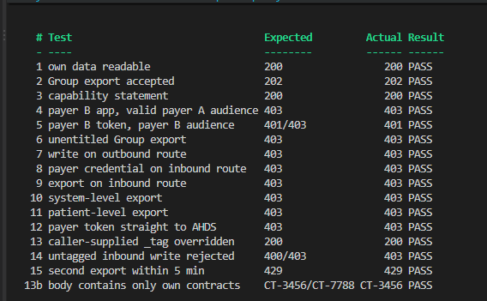

Baseline — prove the door opens
# | In plain words | Expect
1 | Contoso reads its own patients | 200
2 | Contoso starts a bulk download of one of its groups | 202
3 | Anyone asks "what can this service do?" | 200
Payer boundary — you cannot reach the other payer's data
# | In plain words | Expect
4 | Fabrikam's app, holding a properly-made ticket for Contoso's door, tries Contoso's data | 403
5 | Fabrikam's app with its own ticket tries Contoso's door | 401 or 403
Contract boundary — inside a payer, you only get your own contracts
# | In plain words | Expect
6 | Contoso tries to bulk-download a group it was never given | 403
Direction boundary — the two doors do different jobs
# | In plain words | Expect
7 | Try to write data on the read-only (outbound) door | 403
8 | Use a payer's ticket on the inbound door, which isn't for payers | 403
9 | Try to start a bulk download on the inbound door | 403
Export scope — no "give me everything" downloads
# | In plain words | Expect
10 | Ask to export the whole service | 403
11 | Ask to export all patients | 403
Bypass — the keystone
# | In plain words | Expect
12 | Skip the gateway entirely; take the payer's ticket straight to the health data service | 403
Data integrity — check the answer, not just the status
# | In plain words | Expect
13 | Contoso asks to be labelled as Fabrikam's contract | 200 — the request is ignored, not refused
13b | Read the returned records one by one | only Contoso's own contract present
14 | Push data in the inbound door with no contract stated | 400 or 403

Load
# | In plain words | Expect
15 | Start a second bulk download within five minutes | 429 — wait your turn

Value
It turns their security design from a document into something executable: sixteen calls they can re-run after every policy change, in CI or before a release, that prove payer isolation still holds on the real deployed gateway rather than on a diagram. That gives their security review actual evidence — including test 12, which shows a payer cannot reach the data even with APIM removed from the path — and it means a future change that quietly breaks isolation fails a test instead of reaching production.

